Portfolio 1.1

**Title**

Robot Expo

**Developer**

WIMP Engineering R & D Consultants

**Objective**

Our main objective behind to develop this website is to showcase various types of robots from various fields like education, industry, military etc. and introduced our floor plan and business hours of RoboExpo exhibition.

**Important Points**

* Our RoboExpo company logo is present on each page that we have developed.
* Navbar that we developed is totally responsive using pure CSS.
* We elaborate RoboExpo floor plan on Home Page that is Index.html
* Other pages that are related to robot categories are accommodated in Navbar that are,

Domestic Robots (DomesticRobots.html)

Industrial Robots (IndustrialRobots.html)

Military Robots (MilitaryRobots.html)

Special Demo / Educational Robots (SDER.html)

* Navbar also contains Business Hours page and Copyright Notice page that are,

Business Hours (BusinessHours.html)

Copyright Notice (CopyrightNotice.html)

* Every page has a Copyright Notice at the bottom that is,

“Copyright © Robot Expo 2019”

* All categories contain robots list which is related to that category only like,

Military Robot’s webpage contains following robots,

Samsung Sentry

UAV Predator

ABB Robot

Big Dog

Foster-Miller Bomb Disposal

**Content**

There are total 29 HTML pages, 2 CSS files and 24 images which are jpg and png types.

* **Index.html**

Index file contains website logo which is directly link to homepage after click on that.

Navbar contains all robot categories.

Floor plan about website.

At the bottom Copyright Notice.

* Individual page for each robot category and each category contain robots list which is related to that category only like,

Military Robot’s webpage contains following robots,

Samsung Sentry

UAV Predator

ABB Robot

Big Dog

Foster-Miller Bomb Disposal

Each Military robot has its own webpage to display all information about it.

* Business Hours webpage contains working hours and entrance fees of adults, children and senior citizens.
* Copyright Notice page contains information about IPR and other copyright information.

**Audience**

The user audience of RoboExpo website is Robots savvy students, companies which are already in robot market, AI Start-Ups, Defence Ministry undertaken private robot companies, Automobile companies, heavy machinery manufacturing companies for industrial robots, Smart Schools for educational robots and people working in these field are most likely to be our audience.

**Architecture**

Well organized and easy to use website. All content that we used is understandable, clear and express our objective very well to our end user. All images that we have used is very clear.

Portfolio 1.2

**Index.html**

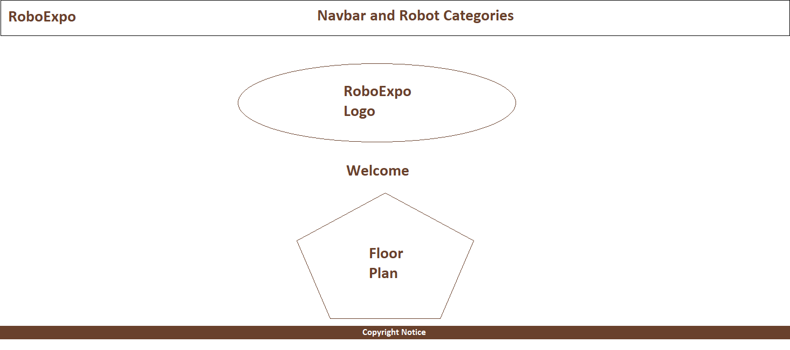

Index file contains website logo which is directly link to homepage after click on that.

Navbar is totally responsive.

Elaborate RoboExpo floor plan on Home Page that is Index.html

Other pages that are related to robot categories are accommodated in Navbar that are,

Domestic Robots (DomesticRobots.html)

Industrial Robots (IndustrialRobots.html)

Military Robots (MilitaryRobots.html)

Special Demo / Educational Robots (SDER.html)

Navbar also conStains Business Hours page and Copyright Notice page that are,

Business Hours (BusinessHours.html)

Copyright Notice (CopyrightNotice.html)

Floor plan about website.

At the bottom Copyright Notice.

**Gallery page of each robot category**

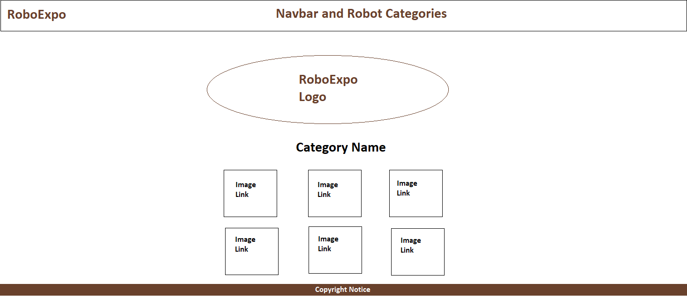

Each image is related to that respective category and after click on image its redirects to webpage that contain that particular robot details with image.

Hover image is applied on each image after mouser hover on image we can see some transitions and title of that image.

**Robot description page**

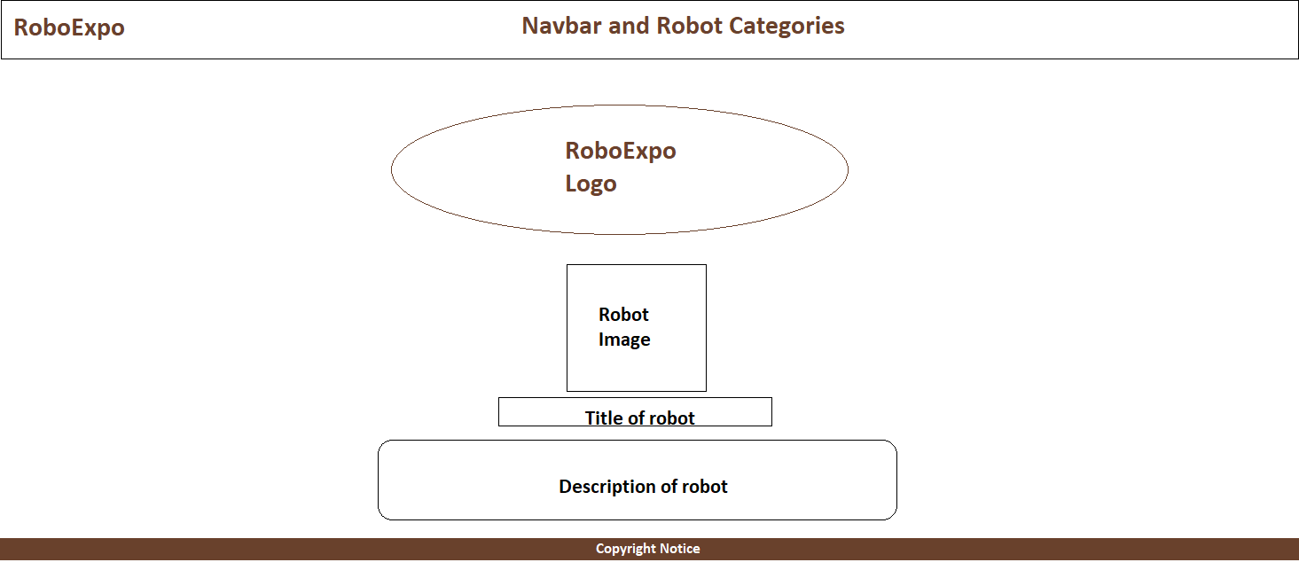

Robot description page contains in centre 400 X 400 robot image, title of that robot and some description about that robot.

**Business hours webpage**

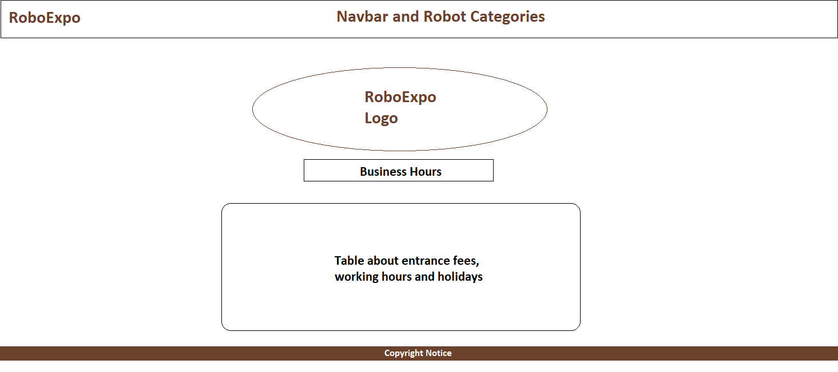

Webpage contains table of working hours, holidays and entrance fees of adults, children and senior citizens.

**Copyright Notice webpage**

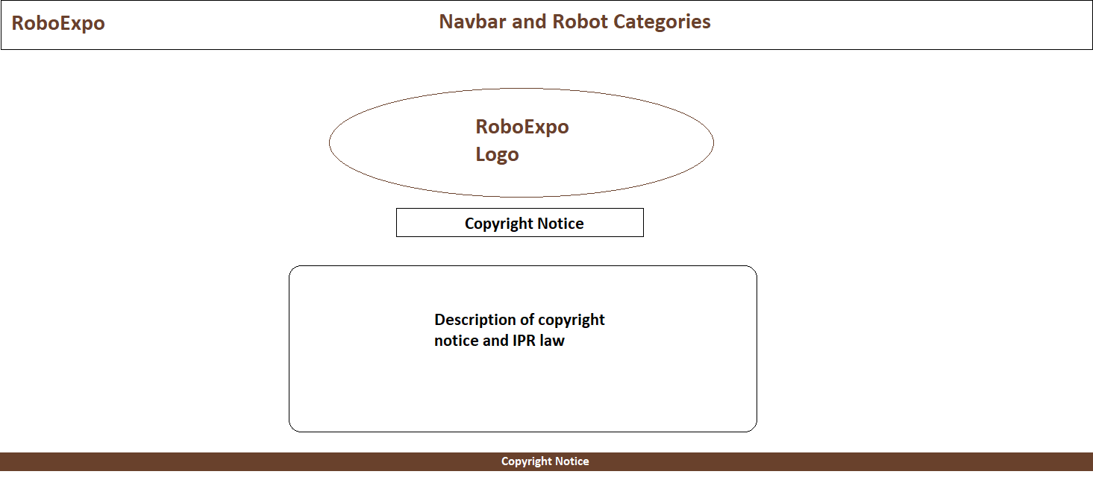

Webpage contains information about IPR law and other copyright information.

Portfolio 1.3

**Mission**

Our mission is to showcase various types of robots from various fields like education, industry, military etc. and elaborate information about each robot and explain functioning of robots.

**Specifications**

To fulfil above objective and develop this webpage bug and error free. Try to improve performance and make it more attractive.

**Audience**

The user audience of RoboExpo website is Robots savvy students, companies which are already in robot market, AI Start-Ups, Defence Ministry undertaken private robot companies, Automobile companies, heavy machinery manufacturing companies for industrial robots, Smart Schools for educational robots and people working in these field are most likely to be our audience.

**Content**

Index file contains website logo which is directly link to homepage after click on that.

Navbar contains all robot categories.

Floor plan about website.

At the bottom Copyright Notice.

Individual page for each robot category and each category contain robots list which is related to that category only

Each Military robot has its own webpage to display all information about it.

Business Hours webpage contains working hours and entrance fees of adults, children and senior citizens.

Copyright Notice page contains information about IPR and other copyright information.

**Well organized website**

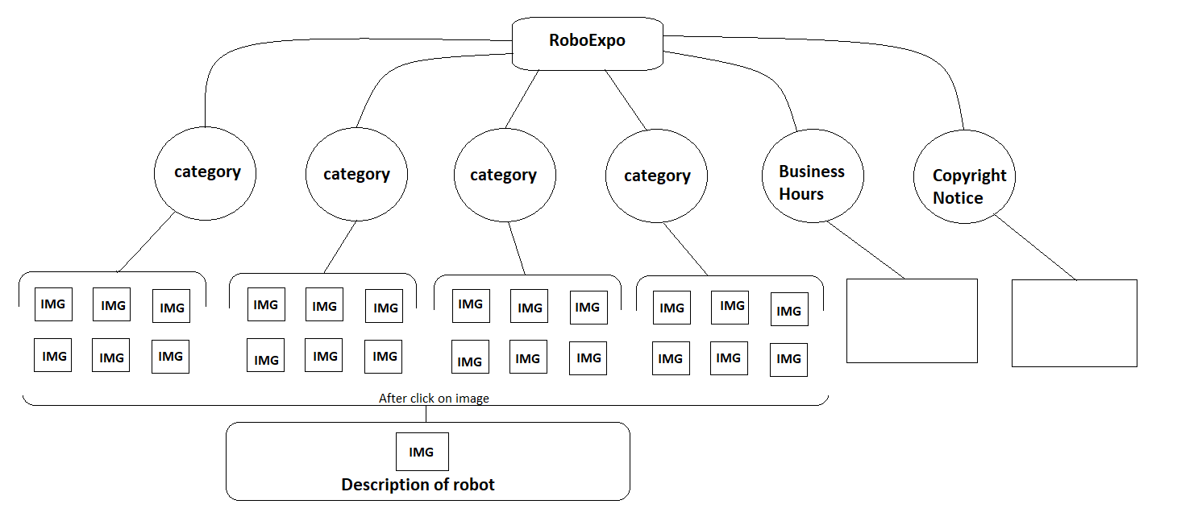

**File Structure**

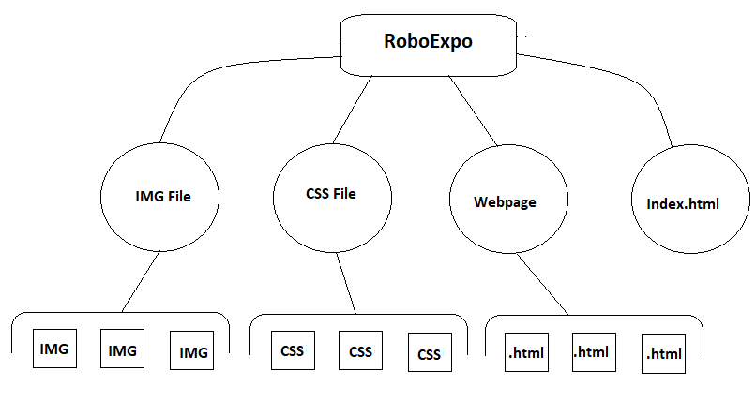

Above diagram shows that all image files are stored in “img” folder.

All CSS files are stored in “css” folder.

All webpages that are individual robot description pages are stored in “robot webpages” folder.

Index.html file, robot category file like, DomesticRobots.html, Business Hour and Copyright Notice HTML files are in main folder.

Portfolio 1.4

We create different directories for each individual extensions elements like, for all CSS files are stored in “css” folder, all image files are stored in “img” folder. Use external type of CSS.

There are 2 CSS files one for common css styles and second one for giving styles for photo gallery all transition effects CSS coding is in PhotoGallery.css file.

Common css tags like width, font-family, height, border, hover, background-color, display, padding etc. to make website more attractive.

**Most common class name that used**

Active

Width-80

Width-60

Text-align-center

Hover01

Column

Footer

Page-body

Nav, nav-header, nav-links

Portfolio 1.5

* Font is used in website is “**segow ui”**.
* Navbar height is “**50 pixel”** and width is “**100%**”.
* Navbar position is fixed on scrolling and background color is “**white**”.
* Use “**h1**”, “**h4**” and “**b**” tags use for text.
* Image height is “**400 pixel**” and width is “**400 pixel**”.
* Links and most of font is in brownish color.( #5a0b0bb3)

Portfolio 1.6

